Biography of Noella Sudbury, JD
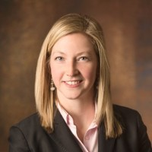
Noella Sudbury is the Director of the Salt Lake County Criminal Justice Advisory Council and serves as a Senior Policy Advisor on Criminal Justice to Mayor Ben McAdams. Noella has a B.A. in Political Science, a B.U.S. in Social Justice, and is a 2009 graduate of the S.J. Quinney College of Law. Following law school, Noella clerked for the Honorable Justice Ronald E. Nehring, of the Utah Supreme Court, practiced criminal defense as a public defender and in private practice, and worked as a Vice President and manager of Government Interactions Compliance at Goldman Sachs. Noella is a past president of the Women Lawyers of Utah, and in 2018, Noella was awarded the Citizen Service Award from the Unified Police Department and the Young Alumna of the Year award from the University of Utah S.J. Quinney College of Law.

